BOSTON UNIVERSITY

COLLEGE OF ENGINEERING

ME306 INTRODUCTION TO MATERIALS SCIENCE

**LAB No. 1 Microstructural Characterization PRE LAB**

[Version Spring 2014]

1. Label the primary parts of the optical microscope. Write the steps for obtaining a well-focused view.

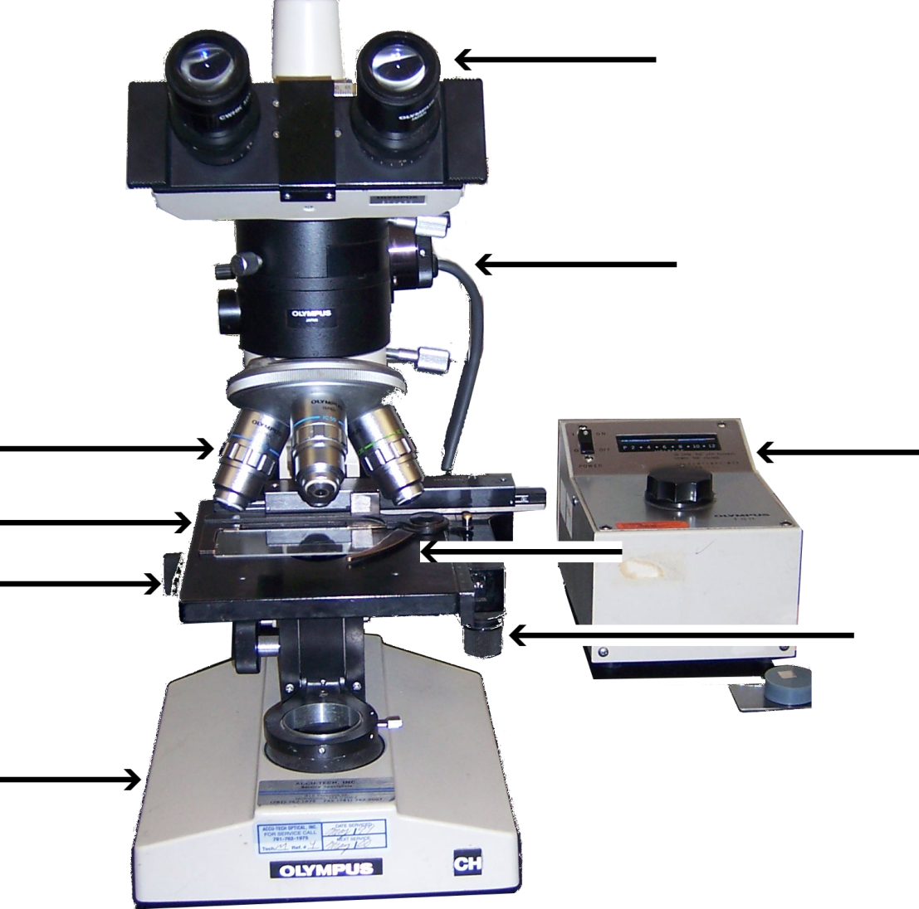

|  |
| --- |
|  |
|  |
|  |
|  |

2. What is the difference between grinding and polishing?

|  |
| --- |
|  |
|  |
|  |
|  |

3. Explain the purpose of etching for this lab?

|  |
| --- |
|  |
|  |
|  |
|  |

4. Discuss the significance of the Rockwell hardness and Knoop micro-hardness tests? (Hint: What do the results from the tests infer?)

|  |
| --- |
|  |
|  |
|  |
|  |

5. How can you determine grain size using the optical microscope and magnification conversion chart?



  
  
  
  
  
  